Colon Cancer and Liver Metastasis.
Stem: 70 year-old male was found to have a biopsy proven descending colon adenocarcinoma while undergoing work-up for anemia. Staging work-up included CT CAP with IV and PO contrast which demonstrated a single 4cm mass in the left lobe of the liver, no other distant metastatic disease identified, CEA elevated at 200.

What is your r differential diagnosis?
- Malignant – metastatic disease (most likely), primary HCC, intrahepatic cholangiocarcinoma
- Benign - cyst, hemangioma, FNH, hepatic adenoma
What Workup would you do?
-Hepatic MRI with IV contrast –Li kely with metastatic disease isolate to segment 3 and no additional metastatic foci, no extrahepatic disease and no portal lymphadenopathy. .d
-IR guided biopsy –Consistent with colon adenocarcinoma as primary (No penalty if resident skips)
What is your management plan?
- Multidisciplinary tumor board discussion.
- Approaches (acceptable)
  - Neoadjuvant therapy FOLF OX (if this approach used then surgery should be undertaken after 3-4 cycles) followed by synchronous or staged colectomy and liver resection.
  - Upfront Synchronous or staged colectomy with liver resection followed by chemotherapy
  - Colectomy followed by chemotherapy and staged resection of metastatic disease.
  - Liver resection followed by chemotherapy then colectomy.

What If widely metastatic and not amenable to resection?
- chemotherapy with interval reevaluation.

Scenario :65 year old man who was diagnosed with sigmoid adenocarcinoma with small, diffuse liver metastases present on diagnosis now presents o cycle 4/12 of FOLFOX + with abdominal pain, distention nausea or vomiting. How would you proceed?and some
- CT Abdomen / Pelvis : Dilated colon with transition point at sigmoid colon where known tumor malignancy is. Small bowel is not significantly dilated.
How would you manage?
Hold further chemo. Timing of intervention? Ie this admission? If yes then what would be the best time given they are actively getting chemo
- Endoscopic stenting
- Diverting loop colostomy

Sarcoma.
Stem: A 55-year-old male presents to your office after being referred from his PCP for further valuation of an asymptomatic mass on his right inner thigh.
PMH: None. Family history is noncontributory.
PE: There is poorly defined posterior right thigh mass, approximately 8 cm in diameter (specify compartment, posteriormedial in this case based on picture, involving the hamstrings)
Labs: Not significant.

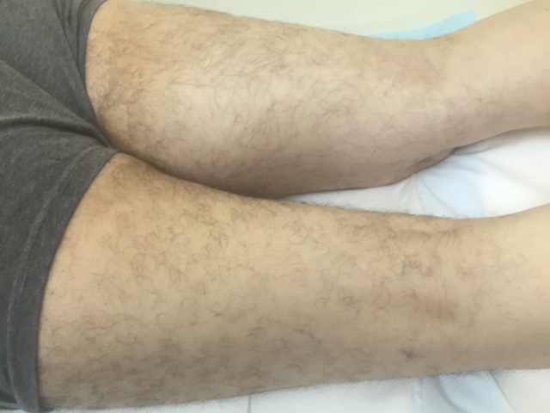
Describe how you would work up and manage this mass?
- Plain radiograph of the thigh: Soft tissue mass with fat density (Need to start with plain radiograph to r/o periosteal or bone involvement)
- MRI of the entire muscle compartment: Soft tissue mass, with low signal intensity on T1 and high signal intensity on T2
- Obtain image-guided core needle biopsy with multiple passes of 18g needle with site incorporated into possible resection margin →pathology:high grade pleomorphic sarcoma
- Staging workup: CT of chest
What if the core needle biopsy came back as non-conclusive? -Obtain incisional biopsy-describe Technique.-Along the axis and don’t develop fascial planes.
Mass is high grade, how would you approach this mass from an operative standpoint?
Radiate first
- limb salvage.
- Excision outside the pseudocapsule.
- Radical resectionof the muscle compartment Preserve sciatic

When Is amputation indicated? - Inability to resect without amputation,
nonfunctional limb

Scenario : A 32-year-old man with a history of FAP presents with a 15-cm firm mass in the right axilla that restricts his range of motion. A CNB confirms a desmoid tumor, imaging doesn’t show nerve involvement, patient requests excision, how would you council them regarding risk of recurrence. ?

- >50% chance of recurrence even with R0 resection

What if the mass was asymptomatic? -
- Observe.
- Consider medical management with sulindac or other NSAIDs or tamoxifen.

What if this was a 32-year-old female and the mass was discovered during
pregnancy?
- Post-partum give sulindac or tamoxifen or observe.
- Most regress once hormonal stimulation removed.

Scenario 3: A 62-year-old man is seeing you in your office for the first time. He previously underwent exploratory laparotomy and resection of dedifferentiated liposarcoma 3 years ago and has now developed vague symptoms, including early satiety and abdominal bloating. He was lost to follow-up after his initial surgery. What would you recommend?
- Suspect recurrence

- Complete imaging workup including CT Chest/Abd/Pelvis

Your work up shows recurrence , when would recurrence be resectable?

- In general , surgery is
- indicated if R1 resectionpossible

What if unresectable? recurrence → chemotherapy (ifosfamide/doxorubicin)

Hepatic Abscess
Stem: You are called to the ED to see a 78 yo man who presents with 3 day history of fevers and chills, sweats and feeling poorly. He reports RUQ abdominal pain and some nausea but no emesis. He is otherwise healthy.
Vitals: T=99.9 degrees, BP=100/60, HR 110, and RR of 20.
Physical exam : Tender to palpation in the right upper quadrant without guarding or peritoneal signs.
Labs: WBC of 18K, LFTs slightly elevated, otherwise rest of labs normal.
PMH/PSH: Diverticulitis. Colonoscopy 1 year ago with diverticulosis

What Studies you would like to obtain to help you narrow the differential diagnosis?
- RUQ US: 7 cm fluid mass in the right lobe of the liver
- CT Abd/Pelvis with contrast :7 cm fluid, with hyperenhancing rim and few air bubbles within it.
Based on these findings what is your differential diagnosis?
- Pyogenic liver abscess.
- Amoebic liver abscess.
- Simple cyst, infected.
- Echinococcal cyst
How would you manage it?
- IV access: Fluid resuscitation.
- Broad spectrum Abx to cover GI Flora.
- Look for primary source if suspecting pyogenic abscess.
- Serologic testing if concerned about amoebic abscess
- IR drainage.
- Obtain pertinent history such as travel, IV drug use, endocarditis hx, valvular disease, dental work, immunocompromised etc

Scenario 1: CT showed 3cm abscessnot easily accessible by IR?
- long term antibiotics alone, in a stable patient may be reasonable. If gets worse, may need OR instead of IR.
Scenario 2: P atient presents in shock, hemodynamically stabilizes with resuscitation and able to proceed to CT. Findings included Intraperitoneal rupture/peritonitis? IR not available immediately and patient becomes hypotensive again?
- Patient should proceed to OR for operative debridement/drainage.
- Laparoscopic approach is preferred over open approach.
- Intraoperative US should be done to confirm complete drainage and not to miss another abscess).
Scenario 3:Patient presents with 5cm liver abscess and cholecystitis, confirmed by HIDA; how would you proceed?
1. If frail, IR perc chole tube and IR drainage of abscess with IV abx reasonable.
2. If not frail, proceed to OR for lap chole and drainage of abscess; IV abx.
Scenario 4:Same patient – serologic testing is positive amebic abscess. How would you treat him?
- IV metronidazole -- very high efficacy.
- Aspiration: reserve for very large abscess (if doesn’t get better with abx fast, etc).

